

24ADC001- BUSINESS INTELLIGENCE

--------------------------------------------------

2026-2027
LAB RECORD

DEPARTMENT OF ARTIFICIAL INTELLIGENCE AND DATA SCIENCE

INDEX
Expt. No | Title of the Experiment | Page No | Total Marks | Faculty Signature
1. | Explore the interface and basic features of the BI tool
2. | Load and visualize a sample dataset.
3. | Import a dataset into the BI tool. And Cleanse data by handling missing values, outliers, and  inconsistencies.
4. | Transform data to suit BI reporting requirements and Design a dashboard with  key performance indicators (KPIs).
5. | Develop interactive dashboards for dynamic data exploration.
6. | Integrate data from various sources for comprehensive analysis
7. | Implement advanced chart types (treemaps, heatmaps, etc.).
8. | Apply BI tools for forecasting and predictive analytics.

Average marks Faculty Signature

EXPT NO:1 | EXPLORE THE INTERFACE AND BASIC FEATURES OF BI Tool
DATE: 10.07.2026

PRE-LAB QUESTIONS (PROVIDE BRIEF ANSWERS TO THE FOLLOWING QUESTIONS)

1. What is the purpose of Business Intelligence (BI) tools like Tableau and Power BI?
Business Intelligence (BI) tools like Tableau and Power BI help organizations analyze, visualize, and understand large amounts of data. They convert raw data into meaningful charts, graphs, and dashboards that support informed decision-making. These tools enable users to identify trends, monitor business performance, and generate reports quickly. BI tools also provide interactive features, making it easier to explore data, compare results, and gain valuable insights for business growth and strategic planning.

2. List any three common data sources that Tableau and Power BI can connect to.
Tableau and Power BI support connections to a wide range of data sources for analysis and reporting. Three commonly used data sources are Microsoft Excel files, CSV (Comma-Separated Values) files, and SQL databases such as MySQL or Microsoft SQL Server. They can also connect to cloud platforms, Google Sheets, and web services. This flexibility allows users to combine data from different sources and create comprehensive business intelligence dashboards.

3. What is a dashboard in BI, and how is it different from a single chart?
A dashboard in Business Intelligence is a collection of multiple visualizations displayed together on a single screen to provide an overall view of business performance. It combines charts, graphs, filters, and key metrics into one interactive interface. In contrast, a single chart represents only one aspect of the data. Dashboards allow users to explore different perspectives simultaneously and make better decisions by comparing multiple insights in one place.

4(a). Define Visualization.
Visualization is the process of representing data in graphical formats such as charts, graphs, maps, and dashboards. It helps users understand complex information quickly by highlighting patterns, trends, and relationships that may not be obvious in raw data. Effective visualizations improve communication, simplify data analysis, and support better decision-making. Business Intelligence tools like Tableau and Power BI provide various visualization options to make data more meaningful and easier to interpret.

4(b). Define KPI.
A Key Performance Indicator (KPI) is a measurable value used to evaluate how effectively an organization, team, or individual is achieving specific objectives. KPIs help monitor business performance and measure progress toward goals. Examples include total sales, profit, customer satisfaction, and revenue growth. In Business Intelligence tools, KPIs are often displayed using cards, gauges, or dashboards, allowing decision-makers to track important metrics and identify areas that require improvement.

4(c). Define Data Filter.
A data filter is a feature that allows users to display only the information that meets specific conditions or criteria. It helps focus on relevant data while hiding unnecessary records, making analysis more efficient. Filters can be applied based on categories, dates, regions, or numerical values. In Tableau and Power BI, filters improve dashboard interactivity by enabling users to explore different subsets of data and generate customized insights easily.

5. Why is it important to clean and transform data before visualization?
Cleaning and transforming data before visualization ensures that the analysis is accurate, reliable, and meaningful. Data cleaning removes missing values, duplicates, and incorrect records, while transformation organizes data into a suitable format for analysis. Poor-quality data can produce misleading charts and incorrect conclusions. By preparing the data properly, Business Intelligence tools can generate clear visualizations that support better decision-making and provide trustworthy insights for business analysis.

6. What kind of chart would you use to analyze stock price trends over time?
A line chart is the most suitable visualization for analyzing stock price trends over time. It displays changes in stock prices across different dates, making it easy to identify trends, fluctuations, and long-term performance. The horizontal axis represents time, while the vertical axis shows stock prices. Line charts help investors and analysts compare historical performance, identify patterns, and make informed financial decisions based on market movements.

7. Explain the role of slicers in Power BI and filters in Tableau.
Slicers in Power BI and filters in Tableau allow users to interactively control the data displayed in reports and dashboards. They help users focus on specific categories, dates, regions, or other conditions without modifying the original dataset. By selecting different filter values, visualizations update automatically to show only relevant information. These features improve data exploration, enhance user experience, and support more flexible and efficient business analysis.

8. What does a calculated field or measure do in BI tools?
A calculated field or measure allows users to create new values by performing calculations on existing data. It is used to derive additional insights that are not directly available in the dataset. Examples include calculating profit margins, prediction errors, growth percentages, or average sales. In Tableau and Power BI, calculated fields help automate computations, simplify analysis, and create customized metrics for reports, dashboards, and business decision-making.

9. What are the advantages of using interactive dashboards for financial data analysis?
Interactive dashboards provide a dynamic way to analyze financial data by combining multiple visualizations in one interface. Users can apply filters, drill down into details, and compare different financial metrics instantly. They improve decision-making by presenting real-time insights and making complex financial information easier to understand. Interactive dashboards also save time, enhance reporting efficiency, and help identify trends, risks, and opportunities more effectively than static reports.

10. Which function would you use to find the absolute difference between predicted and actual stock prices?
The ABS() function is used to calculate the absolute difference between predicted and actual stock prices. It returns the positive value of the difference regardless of whether the prediction is higher or lower than the actual value. For example, the formula ABS([Predicted Price] - [Actual Price]) calculates the prediction error. This helps analysts measure forecasting accuracy and evaluate the performance of predictive models in financial analysis.

IN-LAB EXERCISE:
Objective:
To understand the basic interface, data import process, and fundamental visualization capabilities of Tableau and Power BI using a stock prediction dataset, and to explore their usefulness in analyzing financial data.

Tools Required:
- Tableau Public / Tableau Desktop
- Power BI Desktop
- Sample Dataset (CSV/Excel) containing:
Date, Stock Name, Open, Close, High, Low, Volume, Predicted Price

Exercise Steps:
Part 1: Working with Tableau
- Launch Tableau and connect to the stock prediction dataset.

Explore the Interface:
  - Understand components like Data Pane, Sheets, Marks Card, and Dashboards.

Create Basic Visualizations:
  - Line Chart: Show Close Price over time.
  - Scatter Plot: Plot Volume vs. Predicted Price.
  - Highlight Table: Display Predicted Price by stock.

Apply Filters:
  - Add filters for Stock Name and Date Range.

Create Calculated Field:
  - Calculate prediction error as |Predicted - Close|.

Design a Basic Dashboard:
  - Combine your charts into one interactive dashboard.
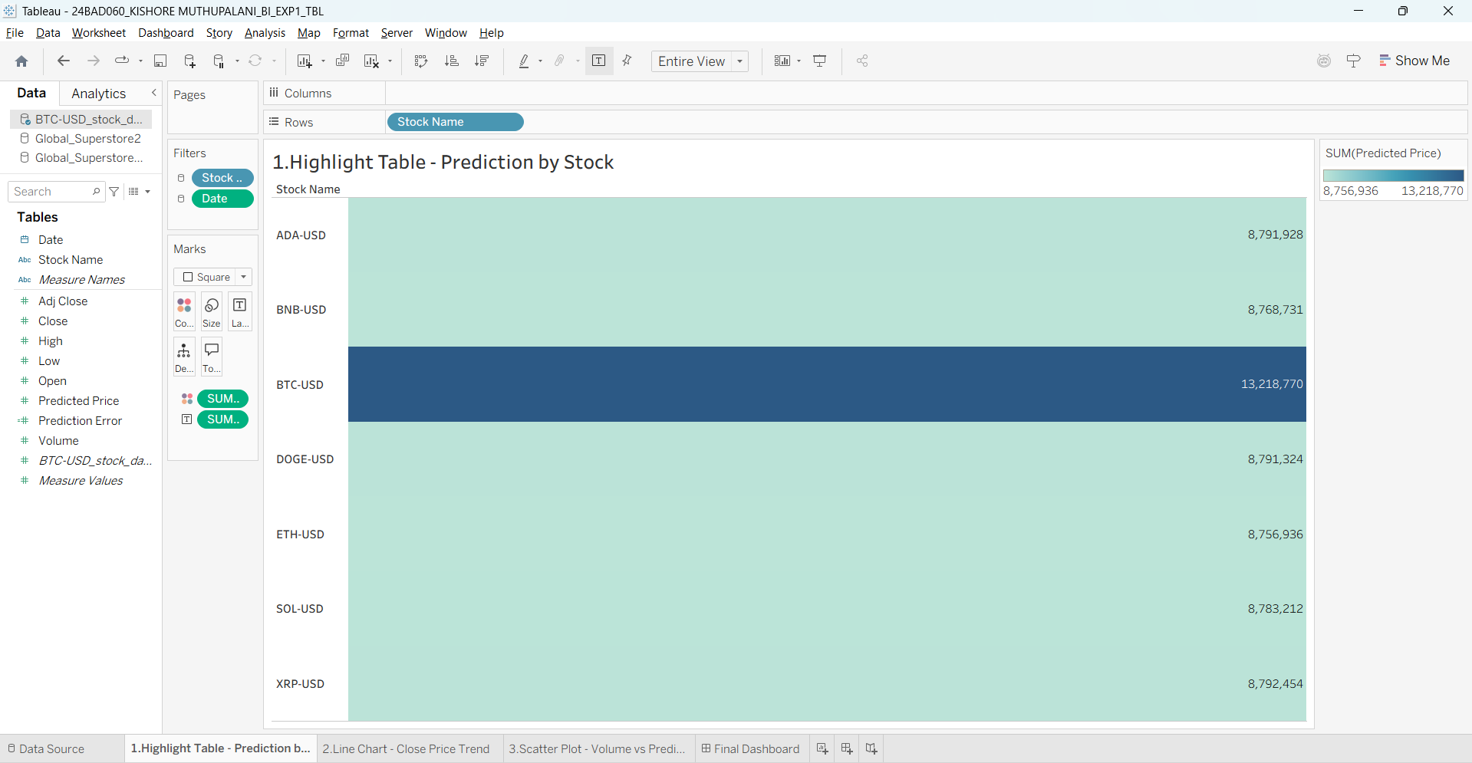

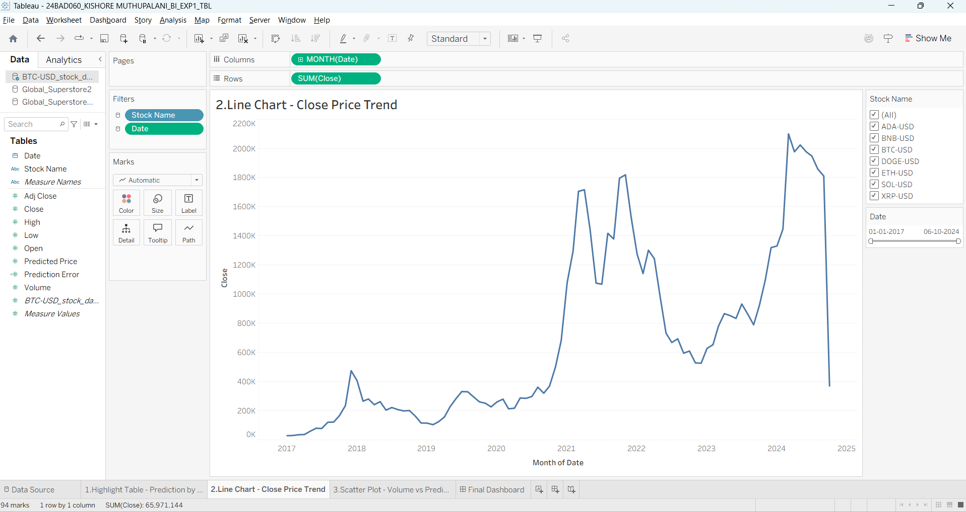

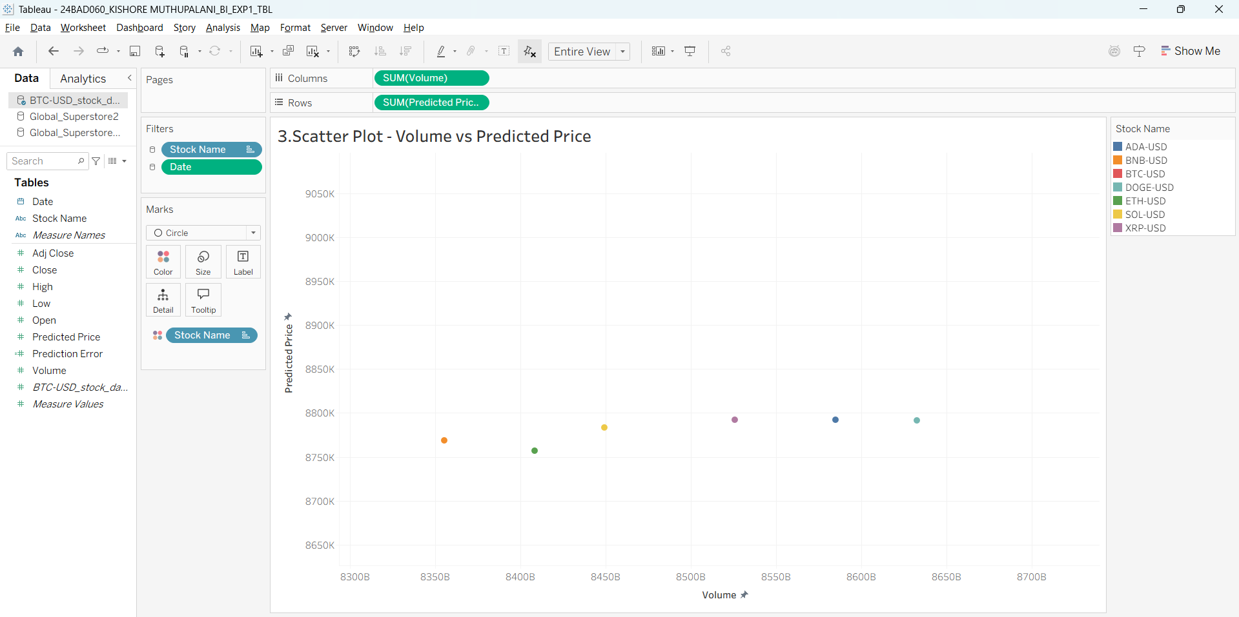

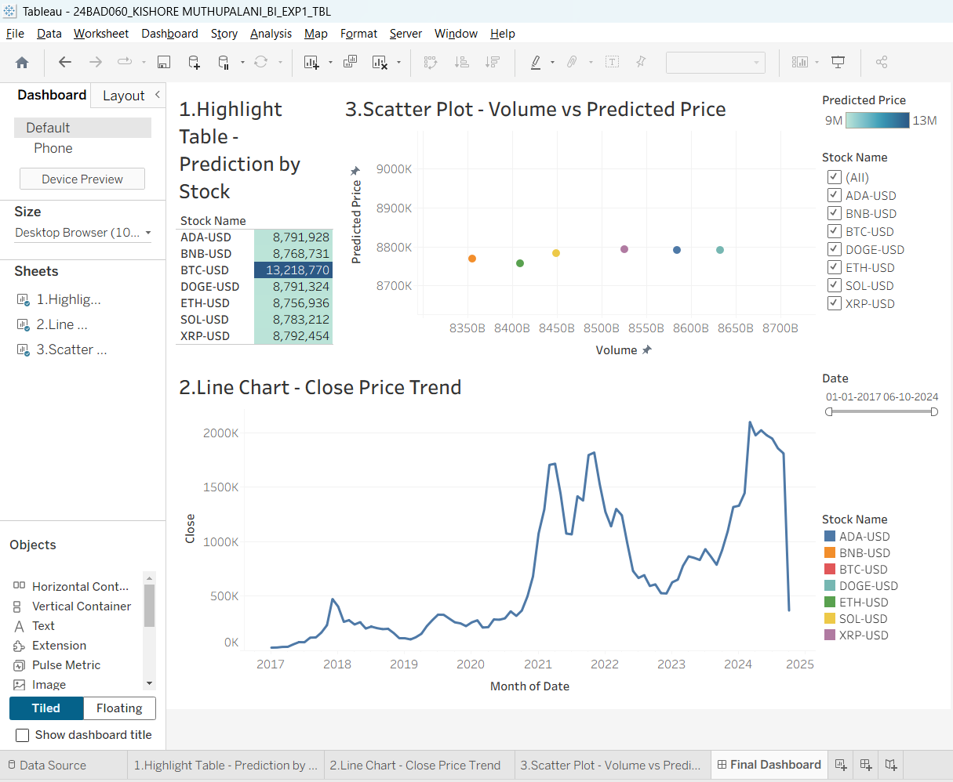

Part 2: Working with Power BI
- Open Power BI Desktop and import the same dataset.

Explore the Interface:
  - Familiarize with Fields Pane, Visualizations Pane, Report View, Data View.

Create Basic Visualizations:
  - Line Chart: Trend of Close Price over time.
  - Bar Chart: Compare Predicted Price vs. Close Price.
  - Card (KPI): Display average prediction error.

Use Filters and Slicers:
  - Filter data based on Stock Name and Date.
- Create a Simple Measure using DAX:
  - Example: Prediction Error = ABS(Predicted - Close)

Build a Report Page:
  - Arrange visuals in a single interactive page.

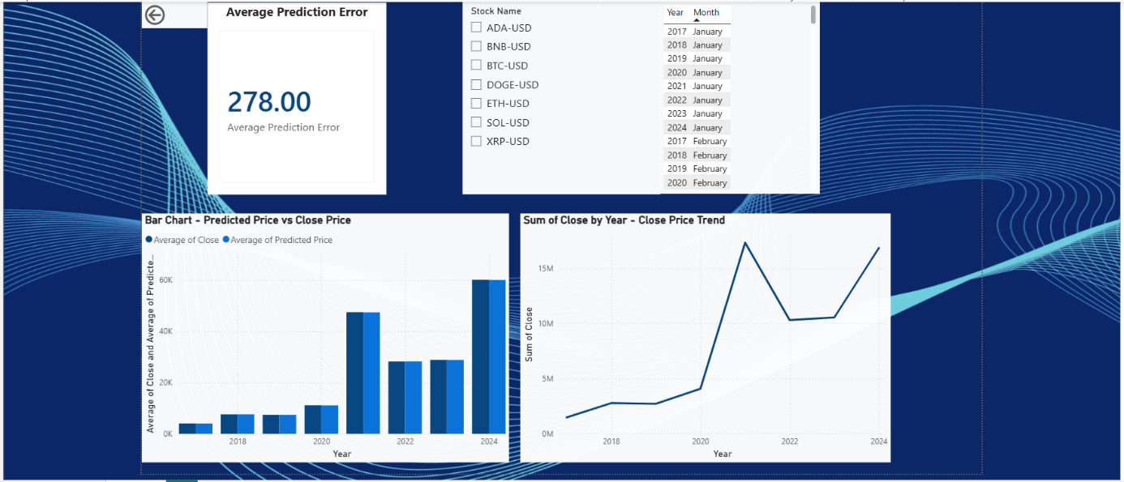

POST-LAB QUESTIONS (PROVIDE BRIEF ANSWERS TO THE FOLLOWING QUESTIONS)

1. Describe your experience with the Tableau interface. What components did you interact with?
Working with the Tableau interface was intuitive and organized. I interacted with the Data Pane to access dimensions and measures, the Rows and Columns shelves to build visualizations, and the Marks card to customize colors, labels, and chart types. I also used the Filters shelf to add interactive filters and the worksheet area to create charts. Finally, I combined the visualizations into a dashboard, making the analysis more interactive and easier to understand.

2. How did you import the dataset into Tableau and Power BI?
In Tableau, I selected Connect → Text File and imported the BTC-USD Stock Prediction CSV dataset. Tableau automatically detected the data types, which I verified before creating visualizations. In Power BI, I used Get Data → Text/CSV, selected the same dataset, previewed the data in the Navigator, and clicked Load. After importing, I checked the fields and data types before starting the visualization process in both tools.

3. What types of visualizations did you create in both tools? List at least two per tool.
In Tableau, I created a Line Chart to visualize the Close Price trend over time, a Scatter Plot showing the relationship between Volume and Predicted Price, and a Highlight Table displaying predicted prices by stock. In Power BI, I created similar visualizations, including a Line Chart, Scatter Plot, and Highlight Table. These charts helped compare stock performance, analyze prediction patterns, and understand relationships between different variables.

4. How did you calculate the prediction error, and how was it displayed in your dashboard?
The prediction error was calculated by finding the absolute difference between the predicted stock price and the actual closing price. In both Tableau and Power BI, I used the formula ABS(Predicted Price – Close Price) to ensure the error was always a positive value. The calculated field was added to the dataset and used for analysis, helping evaluate the accuracy of the prediction model and compare actual versus predicted values effectively.

5. Which filtering or slicing techniques did you apply, and what insights did they reveal?
In Tableau, I applied filters for Stock Name and Date Range to analyze specific stocks over selected periods. In Power BI, I used slicers for the same fields to make the dashboard interactive. These filters allowed me to observe changes in stock prices, predicted values, and trading volume for different time periods. They also made it easier to compare trends and focus on relevant data without affecting the original dataset.

6. Compare the process of creating a line chart in Tableau vs. Power BI. What differences did you notice?
Creating a line chart in Tableau involved dragging the Date field to Columns and Close Price to Rows, after which Tableau automatically suggested a line chart. In Power BI, I first selected the Line Chart visual and then assigned fields to the X-axis and Y-axis. Tableau relied more on drag-and-drop analysis, while Power BI required selecting the visualization type before assigning fields. Both tools produced similar results but followed different workflows.

7. How did you organize the dashboard in Tableau and Power BI? What key elements did you include?
I organized the dashboard by placing the Line Chart, Scatter Plot, and Highlight Table in a structured layout for easy comparison. I included interactive filters for Stock Name and Date Range so users could explore specific data dynamically. Appropriate titles, labels, colors, and tooltips were added to improve readability. The dashboard provided a clear overview of stock price trends, predicted values, and trading volume in a single interactive interface.

8. Which tool (Tableau or Power BI) did you find more user-friendly for financial data visualization, and why?
I found Tableau more user-friendly for creating visualizations because of its simple drag-and-drop interface and automatic chart suggestions. It allowed me to create interactive charts quickly with minimal configuration. However, Power BI offered better flexibility for creating calculated measures and designing business dashboards. For financial data visualization, Tableau made exploration easier, while Power BI provided stronger analytical capabilities and integration with advanced data modeling features.

9. What challenges did you face while creating visualizations or dashboards?
While creating the dashboards, I faced challenges in configuring filters across multiple worksheets in Tableau and ensuring they applied consistently. Selecting the correct chart type and formatting the visualizations for better readability also required careful adjustments. In Power BI, I spent time organizing slicers, formatting visuals, and creating the calculated prediction error measure. These challenges improved my understanding of dashboard design and interactive data visualization techniques.

10. How can the knowledge gained from this lab be applied to real-world financial data analysis?
The knowledge gained from this lab can be applied to real-world financial analysis by creating dashboards that monitor stock prices, evaluate prediction accuracy, and identify market trends. Interactive visualizations help analysts explore historical performance, compare predicted and actual values, and make data-driven decisions. Business Intelligence tools like Tableau and Power BI enable organizations to generate meaningful reports, improve forecasting, and support investment decisions through clear, interactive, and well-structured financial dashboards.

ASSESSMENT

Description | Max Marks | Marks  Awarded
Pre Lab Exercise | 5
In Lab Exercise | 10
Post Lab Exercise | 5
Viva | 10
Total | 30
Faculty Signature

